Spring Oscillation Modelling Project
Adam Hancock

Physical Setup
We have a particle of mass B, suspended between points A and C vertically above and below it. These points are fixed, and each spring has a natural length, and can both extend Initially, the mass is pulled some distance from its equilibrium then released. Alternatively, the system can experience an inputted oscillation. We measure x to be the downwards displacement from displacement at x=0. There is a dampening force equal to k times the velocity.

Assumptions
We assume standard gravity (g=9.8ms⁻²). For the springs, we assume they have tensions proportional to their extension (Hooke’s law), that they are weightless and that they cannot deform. This is not a closed system as there is a damping force included, but it is limited to be proportional to velocity. We assume no air resistance; however, this could be incorporated into the damping coefficient if we follow the basic Stoke’s model of air resistance. Finally, this model only operates in 1 dimension, so orthogonal forces or motion such as swinging in the z-axis is ignored.

Derivation / Governing Equations
We first find the position of the mass at equilibrium; hence the extensions of the springs are the unknows. We have two simultaneous equations, from resolving forces and equating lengths that are:
$${NL}_{A}+{NL}_{c}+e_{A}+e_{C}=AC \& Te_{A}\left(AC-{NL}_{A}-{NL}_{C}-e_{A}\right)+mg.$$
Which have solutions:
$$e_{A}=\frac{T_{C}\left(AC-{NL}_{A}-{NL}_{C}\right)+mg}{T_{A}+T_{C}} \& e_{C}=AC-{NL}_{A}-{NL}_{C}-e_{A}.$$
From here, we use and rearrange Newton’s second law to get the 2nd order ODE:
$$\frac{d^{2}x}{dt^{2}}+\frac{k}{m}\frac{dx}{dt}+\frac{T_{A}+T_{C}}{m}x+0=RHS$$

It is possible to check that the constant term always equals 0, as the tensions and gravity perfectly cancel out the extensions found above. The initial extensions are included in the model and outputted, but for ease I won’t include the expression for the constant term in this report. The RHS can either be 0 or include the forcing term as mentioned earlier.

How the function works
The 15 inputs for the function are: the distance AC, the spring constant and natural length of both springs, an initial offset (to pull the mass away from equilibrium), options to include an inputted oscillation (a forcing term), the gravitational constant (defaulted to 9.8ms⁻²), the number of decimal places to round to in various calculations, the time span to analyse, and toggles for the 3 optional outputs.
Those outputs are key findings such as details about the equilibrium, then optionally, a plot of the mass’ displacement, an animation of the system, and a plot of the different energy stores over time.
The program calculates equilibrium, sets up the differential equation and solves it numerically, using an imported python module called “solve_ivp” from the SciPy library. It is entirely possible to solve this style of ODE analytically which would be more accurate, but this would be cumbersome to code in the general case that I’m dealing with, with little benefit to claim in doing so.
The code can be seen in Appendix A.

Results
The model was inspired by a question on an exam paper I took, which I analysed as below, with the function call:
spring_model(AC=8, T_A=8, NL_A=2, T_C=3, NL_C=3, m=0.5, k=2, offset=0.6, animate=True, energy=True) 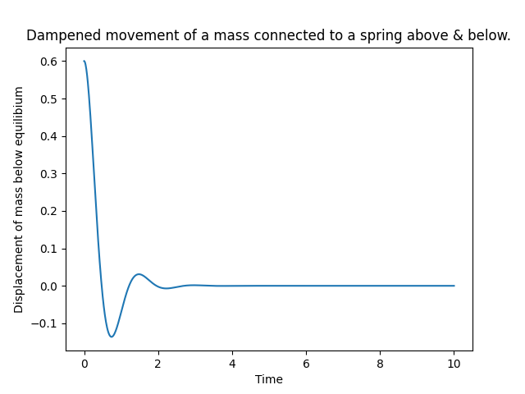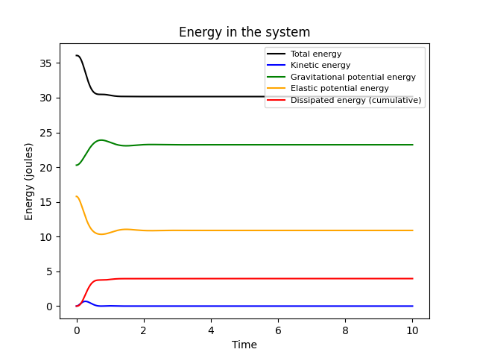

As expected, decreasing the damping force massively increases the number of oscillations before coming to rest, and increasing mass increases the amplitude of those oscillations. Resonance can be observed be setting the frequency equal to $\frac{T_{A}+T_{C}}{m}$, in this case 4.7. Note that the damping force has been decreased so better show this.
spring_model(AC=8, T_A=8, NL_A=2, T_C=3, NL_C=3, m=0.5, k=0.5, offset=0.6, A=5, omega=4.7, animate=False, energy=True)
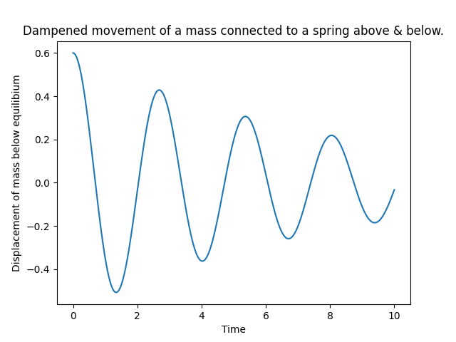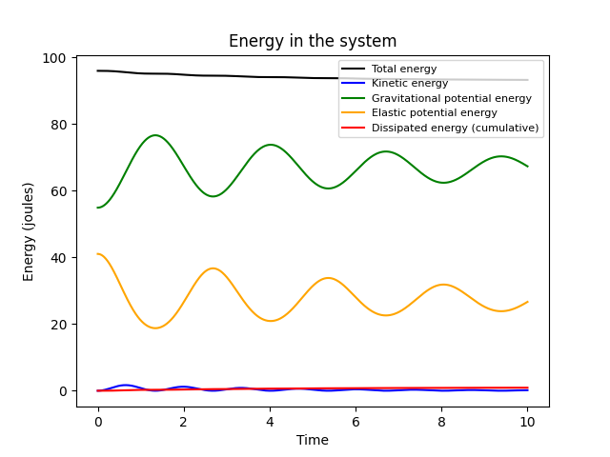

Limitations/improvements
The forcing term is defaulted to a sin function with variable magnitude and frequency, but I should consider adding a third parameter to translate the functions horizontally, thereby allowing the model to accept any input of the form $Acos\left(ωt\right)+Bsin(ωt)$.
The energy calculations are not completely true, as the gravitational energy is measured relative to the equilibrium, allowing for negative energy readings. This could be improved by assuming the model takes place at sea-level and recalculating appropriately.
As mentioned earlier, I could solve the ODE analytically as solutions always exist and it would be to a perfect degree of accuracy.
The animations can’t be displayed as gifs but can be played by running the attached code
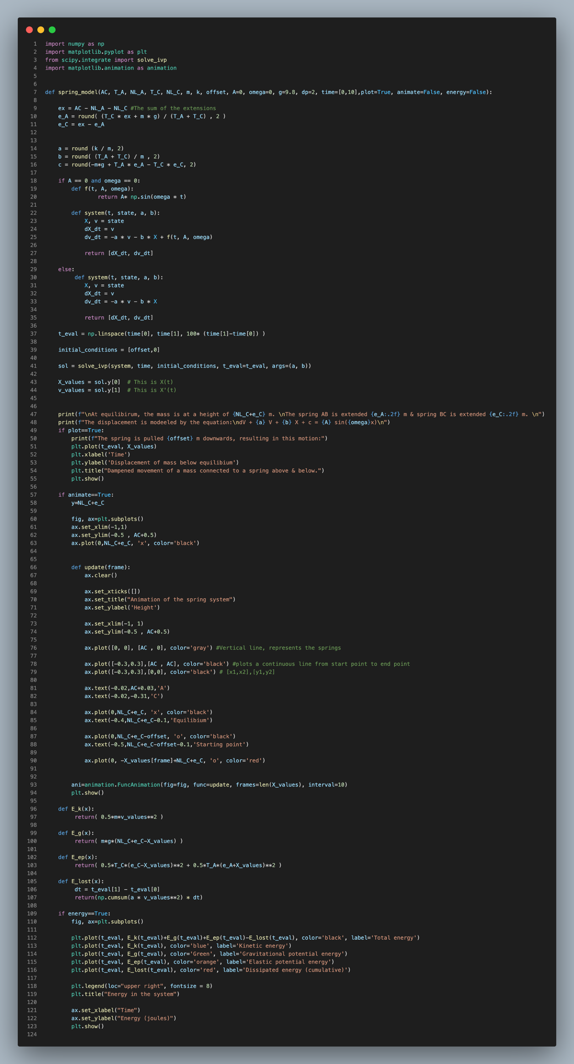
Appendix A: The code

